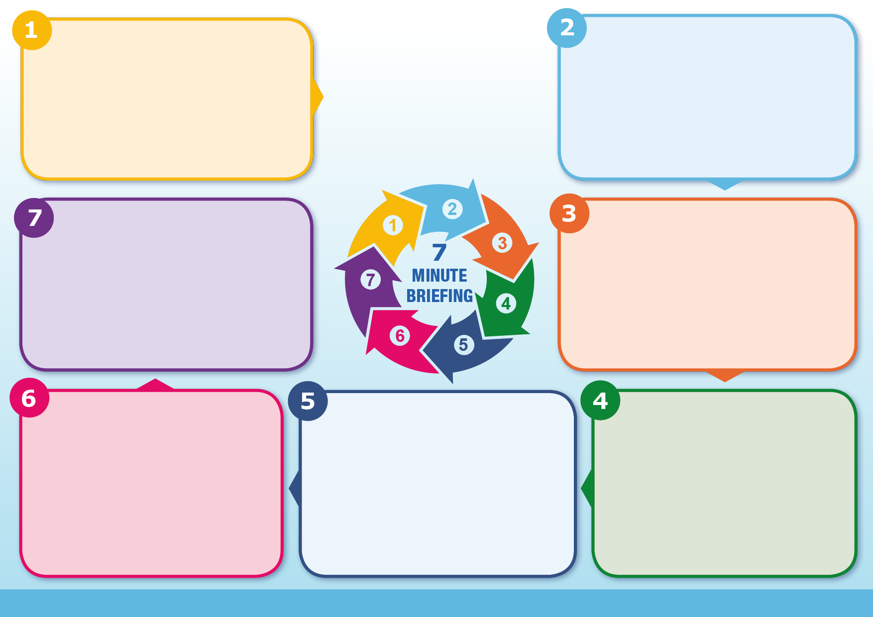

**What is the relevant Legislation?**

NFS is a specific Criminal Offence under DA Act 2021

It is a serious high risk physical violence/assault that typically involves strangling or intentionally affecting a victim's ability to breathe in an attempt to control or intimidate them.

Risk of immediate and long term health damage due to restriction of oxygen to the brain e.g. physical trauma; hypoxic brain injury, devastating psychological effects and can lead to death.

Even a little amount of pressure on the neck can cause serious damage.

In the Domestic Abuse Act 2021, NFS is a specific offence.

The offence applies to any case where a person intentionally strangles or suffocates another person, including in cases of domestic abuse.

The offence will also apply where strangulation or suffocation is committed abroad by a British national or by a person who is habitually resident in England or Wales, as if the offence had happened in England and Wales.

Perpetrators may face up to 7 years in prison if found guilty.

[Non-fatal strangulation or non-fatal suffocation](https://www.cps.gov.uk/legal-guidance/non-fatal-strangulation-or-non-fatal-suffocation) - CPS

[Strangulation and suffocation](https://www.gov.uk/government/publications/domestic-abuse-bill-2020-factsheets/strangulation-and-suffocation) - Government Policy paper

[Why we needed a new Non Fatal Strangulation Offence, explains a forensic physician](https://domesticabusecommissioner.uk/blogs/why-we-need-a-new-non-fatal-strangulation-offence-explains-a-forensic-physician/) - Domestic Abuse Commissioner

[Guidelines for clinical management of NFS](https://ifas.org.uk/guidelines-for-clinical-management-of-non-fatal-strangulation-in-acute-and-emergency-care-services/) - IFAS

[Non-fatal strangulation: a guide for GPs](https://insightplus.mja.com.au/2019/36/non-fatal-strangulation-a-guide-for-gps/) - Insight

[Non-fatal strangulation survey results](https://safelives.org.uk/node/1796) - Safelives

[Institute For Addressing Strangulation](https://ifas.org.uk/) - IFAS

[Compass Domestic Abuse Service](https://www.essexcompass.org.uk/)

Being sensitive and validating the victim's experience.

Using open questions, giving opportunity for the victim to speak about their experience in their own words.

Are you applying trauma informed principles?

Do you know how to instigate the MARAC referral procedures and make a referral?

Do you need to refer to Domestic Abuse Services for safety planning and support?

Do you need to make a Safeguarding referral to Southend, Essex or Thurrock Social Care for children and/or adults?

Do you need to complete a DASH assessment?

**What should you consider?**

Seek urgent medical attention if needed.

If a person could be at immediate risk of harm call 999 and speak to the Police.

Discuss reporting to the Police and seek advice from the Safeguarding Lead if victim declines.

Use professional curiosity and a trauma informed approach to prevent further psychological damage and future risk.

Follow safeguarding procedures to ensure children are protected and receive timely therapeutic interventions.

Submit a MARAC referral.

Comprehensively record findings and actions.

Consult and seek support from your Safeguarding Team/Line Manager or colleagues.

**What should you do?**

NFS is overwhelmingly male against female.

It is a very intimate crime, often committed face-to-face in their own home.

Strangulation is a serious form of physical violence and victims often experience this type of abuse more than once.

Loss of consciousness can occur within 6 to 8 seconds and death in less than 3 minutes.

Some victims do not have any external or visible signs of injury.

Research shows that only 5% of victims seek medical attention.

It is a high-risk marker for potential future serious harm.

Victims are seven times more likely to be murdered by their partner if there has been NFS previously.

Most women were killed by men using a sharp instrument, strangulation and asphyxiation are the second most common method.

During the assault, the victim often fears they will die.

Victims may not disclose or will minimise their experience due to memory loss.

Victims could give a confusing / jumbled account due to lack of oxygen, or fear of the consequences of disclosure.

NFS is often witnessed by children and can result in psychological trauma and is an adverse childhood experience.

**Non-Fatal Strangulation (NFS)**

Developed by the Southend, Essex and Thurrock Domestic Abuse Health Sub-group

**Where can you find more Resources?**

**Why does it matter?**

**What are the key points?**

**What is NFS?**