SETDAB Bulletins Issued January 2021

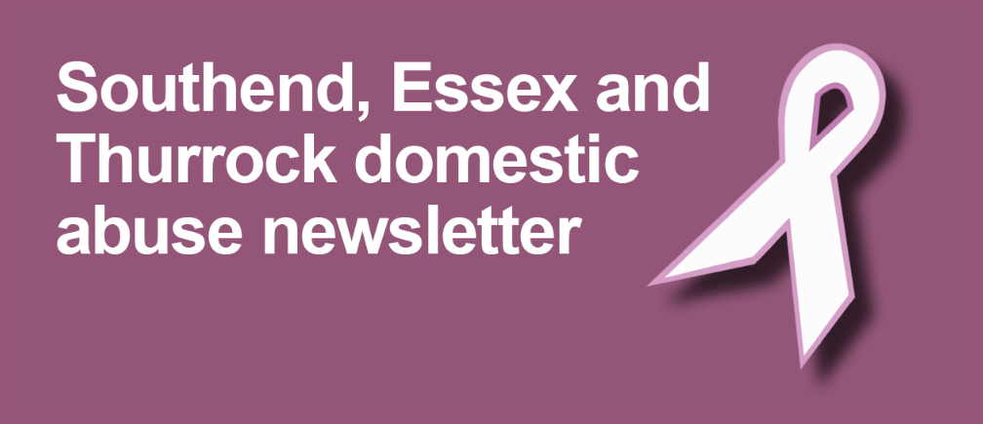

~ Weekly Bulletin ~
Issued on behalf of the Southend, Essex and Thurrock Domestic Abuse Partnership
Essex County Council - Youth Service  Goodman  Good Man is a five week male mentoring programme for young men (10-18yr olds) who are at risk of entering into abusive relationships as perpetrators or victims.  For more details click here.  Prison No Way  Prison No Way supports young people (10-14yr olds) in making good choices and seeing the potential pathway that bad choices could lead to.  For more details click here.  Sisters in Strength  Sisters In Strength is a five week female mentoring programme for young women (10-18yr olds) who are at risk of entering into abusive relationships as perpetrators or victims.  For more details click here.  Safer Places  Virtual Rosie Women's Centre  Safer Places' virtual drop in is open every Tuesday 9.30am – 1pm.  The virtual drop in can support you with the following;  - Domestic Abuse  - Stalking  - Legal rights and access to legal assistance  - Benefits  - Housing  - Emotional support  - Access to refuge or community support  - Access to specialist online programmes  The service is open to anyone who requires support in a confidential and safe manner and will be delivered via Zoom. If you would like to book an appointment please email Rosiecentre@saferplaces.co.uk or call their emergency line on 03301 025811 and quote the 'Rosie Centre'.  Webchat facility  Safer Places' web chat is also open! The service is open to anyone who requires support in a confidential and safe manner and can support you with all the above.  The webchat facility can support you with the areas mentioned above.  If you would like to access this facility please log on to https://www.saferplaces.co.uk/ and select the purple speech bubble in the left hand upper corner. Alternatively please call their emergency number on 03301 0258114. | Feeding into our newsletter  If there is a piece of work, best practice, useful resource or new campaign your agency would like to promote via our weekly bulletin and/or bi-monthly Newsletter please feel free to let the SET DA Team know by emailing us at Domestic.AbuseEssex@essex.gov.uk  Alpha Vesta - Survivors Symposium  Alpha Vesta's Survivors Symposium is the opportunity for those that have been impacted in the workplace by domestic abuse to share their experience with Alpha Vesta, in a confidential and supported setting led by their trained advisors and counsellor(s).  Your experience and story could go on to influence future training for employers and those affected by domestic abuse in the workplace.  You can do this confidentially by sending your thoughts and insight through to survivors@alphavesta.com  *Updated post with correct email

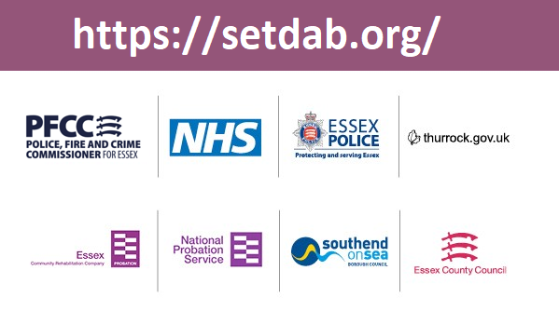
~ Weekly Bulletin ~
Issued on behalf of the Southend, Essex and Thurrock Domestic Abuse Partnership
Alpha Vesta  Alpha Vesta CIC are a community interest company founded last year by Lucy Whittaker with a mission statement of ‘Breaking the cycle of domestic abuse through awareness, prevention and early intervention in the Workplace’.  Alpha Vesta support businesses and organisations to build understanding around domestic abuse, its impact as well as its complexity. This allows staff to recognise the signs and respond within their own workforce as well as amongst those that come into contact with their business or organisation. Through embedding a supportive culture and building understanding, Alpha Vesta enable employees to respond effectively and safely at an earlier point.  Alpha Vesta have lots of information on the impact of domestic abuse in the workplace on their website. To find out more, please click here!  Training Opportunities!  Alpha Vesta are training professionals in a variety of different sectors from the third sector, local authorities, housing and schools to legal, insurance and financial services across the country and globally.  Their four core workshops look at domestic abuse from different perspectives in order to embed culture and build understanding around domestic abuse, it's complexity and it's impact as well as providing robust skills in recognising the signs and responding safely and effectively:-  - Understanding Domestic Abuse and its Impact  - The Complexity of Domestic Abuse  - Impact of Domestic Abuse on Children  - Impact of Domestic Abuse in the Workplace  To find out more about upcoming events Alpha Vesta have to offer please click here.  Please note this training is not delivered or monitored by SETDAB  Survivors Symposium  Ground level research and lived experience underpins all of the work at Alpha Vesta and last month, they were delighted to launch their Survivors Symposium headed up by Fiona Bowman. Their Survivors Symposium is the opportunity for those that have been impacted in the workplace by domestic abuse to share their experience with Alpha Vesta, in a confidential and supported setting led by their trained advisors and counsellor(s).  - Alpha Vesta CIC - Survivors Symposium Launch - Interview with Fiona Bowman on Vimeo  Your experience and story could go on to influence future training for employers and those affected by domestic abuse in the workplace. You can do this confidentially by sending your thoughts and insight through to survivivors@alphavesta.com. | Feeding into our newsletter  If there is a piece of work, best practice, useful resource or new campaign your agency would like to promote via our weekly bulletin and/or bi-monthly Newsletter please feel free to let the SET DA Team know by emailing us at Domestic.AbuseEssex@essex.gov.uk

~ Weekly Bulletin ~
Issued on behalf of the Southend, Essex and Thurrock Domestic Abuse Partnership
J9 Online Training Sessions  Working in partnership with Southend, Essex and Thurrock Domestic Abuse Board, Epping Forest District Council lead on the coordinating the delivery of Community J9 training sessions and the J9 initiative is now recognised widely across Essex. J9 training sessions are intended to raise awareness and increase knowledge and understanding of domestic abuse.  The training aims to ensure that staff are equipped to respond appropriately and effectively. Where the J9 logo is displayed in a window, it alerts victims that they can obtain information which will help them to access a safe place where there can seek information and the use of a telephone.  Training sessions are currently being delivered online via Zoom and take place on:  Tuesday’s at 10am and Thursday’s at 2pm  If you would like more information or to book a space to attend a J9 training session please email: J9community@outlook.com  Stay Safe Webinars - with an exciting new session!  ** Online Safeguarding in Early Years: Keeping young children safe online **  Hot off the press is this exciting new webinar, which will aim to:  - Raise awareness of how young children use technology and the potential risks.  - Explore a range of resources and approaches to help talk to young children about online safety.  - Signpost useful and supportive resources to share with parents/carers.  The webinar will be running Tuesday 9 March 2021 10am-12pm and you can book your place on the ESCB website.  This new webinar is in addition to the existing series of webinars that the ESCB are running through January, February and March. Please see the information below and visit the ESCB website for more information.  - Safeguarding in a desensitised world (CYP First)  - Psychology of the offender (Zoe Lodrick)  - Understanding gangs and criminal exploitation (Craig Pinkney)  - Exploitation and the transition into adulthood (NWG)  For all these sessions, ESCB are really excited to be working with an external facilitator using technology that will allow the sessions to be much more interactive.  #TheHiddenEffects - Al-anon  #TheHiddenEffects – of alcoholism on family and friends. Are you affected?  Al-Anon Family Groups offers free and inclusive meetings for the benefit of the relatives and friends of drinkers. Al-Anon is a members’ fellowship dedicated to helping anyone who has been affected by their relationship with an alcoholic. This relationship can be as close as a parent, child or sibling or as remote as a friend or work colleague.  Al-Anon members provide one another with mutual support, by sharing their experiences with each other.  For support you can contact Al-Anon on their free confidential helpline:0800 0086 811 and more information can be found on their website. | Feeding into our newsletter  If there is a piece of work, best practice, useful resource or new campaign your agency would like to promote via our weekly bulletin and/or bi-monthly Newsletter please feel free to let the SET DA Team know by emailing us at Domestic.AbuseEssex@essex.gov.uk

~ Weekly Bulletin ~
Issued on behalf of the Southend, Essex and Thurrock Domestic Abuse Partnership
What is Ask for ANI?  Ask for ANI (Action Needed Immediately) is a codeword scheme developed by the Home Office to provide a discreet way for victims of domestic abuse to signal that they need emergency help from the safety of their local pharmacy.  The ‘Ask for ANI’ scheme is intended to work alongside and build on existing work and provide an additional tool that can be used to help the most vulnerable victims access emergency support in the community.  How does the scheme work?  Victims of domestic abuse will be able to use the codeword ANI in participating pharmacies (including all Boots stores and participating independent pharmacies) to let staff know that they require an emergency police response or help contacting a helpline or specialist support service.  Participating pharmacies will display posters in their window and around the pharmacy to let customers know that they can approach their staff to seek help. Any information shared will be treated confidentially.  Rock Pool  The Adult Domestic Abuse Recovery Toolkit (DARTK) written by Sue Penna, has been running across the UK within Domestic Abuse Services for over 15 years. The programme is delivered for 2 hours a week in room or 1 hour a week online and over 12 weeks for adults and 8 weeks for Children and Young People (age 8+). The programme uses a trauma-informed psycho-educational model believing that by giving individuals knowledge we enable them to better understand and deal with their previous experiences.  Topics covered in the programme include:  - What is abuse?  - Coping and the consequences on our psychological well-being  - The effects of abuse on children and on parenting skills  - Self-esteem and affirmations and the power of positive self-talk  - Anger, conflict and assertiveness  - Boundaries and trust  - Making mistakes  - Setting goals  - Healthy relationships  The Children and Young People Domestic Abuse Recovery Toolkit is an 8 week peer support programme for any child or young person between the ages of 8 – 16 years who have experienced or witnessed domestic abuse and are able to take part in a group. It is unique in its approach using a combination of trauma-informed cognitive behaviour therapy and person-centred therapeutic principles, that’s strengths based, focusing on resilience and emotional regulation. Children and Young People are facilitated each week to take ownership of their own recovery. This programme has been written for children who are no longer with the abusive parent.  The topics covered in the programme are:  - How abuse affects our thinking  - Self-esteem – what is it?  - Who’s my family?  - Talking positive  - Ways to handle difficult feelings  - Healthy relationships and trust  The training and licence fee to attend the three day Combined Adult and Children and Young People Domestic Abuse Recovery Toolkit course is £750 + VAT per delegate, which is a one-off cost with no recurring licence fee.  Please note this training is not delivered or monitored by SETDAB | Feeding into our newsletter  If there is a piece of work, best practice, useful resource or new campaign your agency would like to promote via our weekly bulletin and/or bi-monthly Newsletter please feel free to let the SET DA Team know by emailing us at Domestic.AbuseEssex@essex.gov.uk

~ Weekly Bulletin ~
Issued on behalf of the Southend, Essex and Thurrock Domestic Abuse Partnership
Substance Misuse Services Update  Substance Misuse Services will remain open during the National lockdown with contingency plans in place as per previous National restrictions. These vary between agencies but include:  - Phone contact to all clients to support/phone assessments as well as emails and texts.  - Face to face appointments are being conducted following Government guidelines, on a case by case basis, and groups are being run online for some services.  - They are taking phone, email and electronic referrals.  - Conducting telephone support with service users and volunteers, wherever possible to use Skype, Microsoft Teams or WhatsApp video calls.  - Service users have been supported with having a “buddy system” where they are in a group chat scenario with others.  For further information and guidance on full contingency plan(s) please contact the appropriate substance misuse agency using the link below to find relevant contact details.  Click here!  SETDAB E'Learning package(s)  Basic Domestic Abuse Awareness eLearning  SETDAB's Basic Domestic Abuse Awareness E-learning package can be accessed, by professionals, via the ESCA Academy partnership e-learning platform.  This site is free to use for organisations across Southend, Essex & Thurrock. Please visit the site and register your details. The e-learning package covers the following learning outcomes:  - To recognise domestic violence and abuse and be aware of the dynamics, impact and the effects on individuals, agencies and society.  - To understand the complexities that often surround Domestic Abuse.  - To be aware of referral pathways for professional support and know how to access it.  To find out more please click here.  Drug & Alcohol Basic Awareness eLearning  You can also access our Drug & Alcohol Basic Awareness eLearning package, which covers the following learning objectives:  - Have an understanding of national drug and alcohol legislation and drug classes.  - Understand the relationship between domestic abuse and substance misuse  - Demonstrate knowledge of physical and psychological addiction.  - Have an understanding of drug categories and side effects.  - Be able to demonstrate knowledge of how to prevent drug related deaths.  - Have knowledge of how to signpost and refer users to local support services.  To find out more please click here. | Feeding into our newsletter  If there is a piece of work, best practice, useful resource or new campaign your agency would like to promote via our weekly bulletin and/or bi-monthly Newsletter please feel free to let the SET DA Team know by emailing us at Domestic.AbuseEssex@essex.gov.uk

~ Weekly Bulletin ~
Issued on behalf of the Southend, Essex and Thurrock Domestic Abuse Partnership
COMPASS - Domestic Abuse Helpline  COMPASS is the single point of access helpline to support victims of domestic abuse across Southend, Essex and Thurrock. Access to your local domestic abuse support services will remain unchanged throughout the national lockdown. The COMPASS helpline 0330 333 7444 is open every day:  - 8am - 8pm, Mon- Fri  - 8am - 1pm Sat - Sun  Outside these hours there is information and national 24 hour numbers available on their website https://www.essexcompass.org.uk where you can also make an online referral and will be contacted within 24 hours.  National Helplines  - National Domestic Violence Helpline - 0808 2000 247  - National LGBT+ Domestic Abuse Helpline - 0800 999 5428  - Respect - 0808 802 4040  - Men’s Advice Line - 0808 801 0327  - Shelter - 0800 800 4444  - NSPCC Helpline - 0808 800 5000  - ChildLine - 0800 1111  - Samaritans - 116 123  The Change Hub  "The Change Hub is committed to offering support to existing and new perpetrator clients throughout the current Lockdown. During this period, we can offer a limited number of face to face appointments at our Chelmsford office or use safe and appropriate alternatives such as telephone/video-calling platforms.  We work closely with DA support services to ensure that associated risks are identified and fully inform our contact decisions, and to monitor all work undertaken with perpetrators."  For further information or to request a referral form, please contact sarah.griffin@thechangeportfolio.org  Multi- Agency Risk Assessment Conference (MARAC)  Southend, Essex & Thurrock MARACs will continue to safeguard high risk victims of domestic abuse and are accepting and responding to referrals.  The MARAC is a regular meeting to discuss how to support and safeguard victims at high risk of murder or serious harm. A domestic abuse specialist (IDVA), police, children’s social services, health and other relevant agencies all share information about the victim, the family and perpetrator, to enable them to devise an action plan to reduce risk for each victim.  Southend, Essex & Thurrock MARACs have produced their contingency plans and these have been enacted since the first national lockdown to ensure the multiagency safeguarding function of MARAC can continue, albeit on a virtual platform.  Southend: Southenddfpsafeguarding@southend.gov.uk  Essex: EssexMARACReferrals@essex.pnn.police.uk  Thurrock: ThurrockMARAC@thurrock.gov.uk  If any agency wants to make referrals into the MARAC process please contact the relevant MARAC (above) to obtain the appropriate form. | Feeding into our newsletter  If there is a piece of work, best practice, useful resource or new campaign your agency would like to promote via our weekly bulletin and/or bi-monthly Newsletter please feel free to let the SET DA Team know by emailing us at Domestic.AbuseEssex@essex.gov.uk

~ Weekly Bulletin ~
Issued on behalf of the Southend, Essex and Thurrock Domestic Abuse Partnership
GamCare  GamCare are facilitating a free online networking event on Wednesday 20th January 10:30 -12:00 to share learning, good practice, and any challenges that have arisen in maintaining positive engagement and mental well-being during COVID-19.  This event is open to anyone with experience for delivering or accessing services in the East of England. Sign up for the event here.  GamCare are also offering free online interactive workshops for anyone working with women and young people who may be affected by gambling and gaming. You can sign up for free training here.  Dealing with cyberstalking: How to lock down your digital privacy  Digital domestic abuse such as cyberstalking is becoming an increasingly prevalent issue which is why Comparitech have prepared this guide.  Comparitech cover everything from cyberstalking laws and how to report cases to practical steps victims can take to protect themselves. The guidance covers a wide range of scenarios as a cyberstalker could of course be an ex-partner or indeed a stranger.  To find out more click here!  Terrence Higgins Trust (THT)  Terrence Higgins Trust (THT) is the UK's leading HIV and Sexual Health Charity, in Essex, THT are working in partnership with Provide CIC, Brook, HLP, SH24, EPUT and East Suffolk and North Essex NHS Foundation Trust to form Essex Sexual Health Service.  THT work on the frontline delivering sexual health promotion in a variety of settings, including education, and offer rapid HIV testing within the community.  They can provide the following –  - HIV Today Community training– 45min – 1hr session of the basics and up to date info around HIV Today  - Basic Sexual Health community training and this can be tailored to your organisations and clients’ needs  - Rapid HIV Testing after the community sessions if felt there was a need along with Chlamydia and Gonorrhoea testing kits.  - We can also provide free condoms to your organisation, they will be provided in a top counter box with around 30 condoms per box, and this can be topped up as and when required.  - They also provide professionals training for work colleagues by logging on to the Eventbrite platform at https://tinyurl.com/thtessextraining or they can come to your work place, and offer a tailored package to suit your organisational needs, all we ask is that there are more than 5 attendees in a work place.  Due to Covid-19 THT are providing training online via Zoom platform, condoms can be posted out to you, but as the restrictions start to ease they shall be starting up face 2 face interventions, this is just a temporary measure.  For further information please do not hesitate to contact THT via email at essex@tht.org.uk | Feeding into our newsletter  If there is a piece of work, best practice, useful resource or new campaign your agency would like to promote via our weekly bulletin and/or bi-monthly Newsletter please feel free to let the SET DA Team know by emailing us at Domestic.AbuseEssex@essex.gov.uk

