****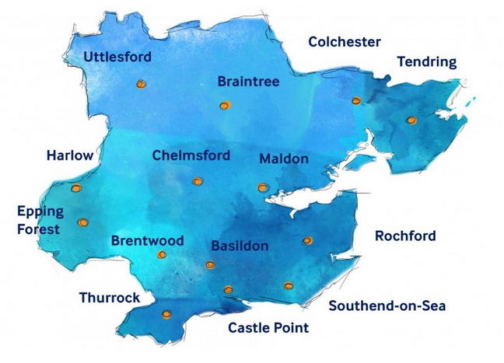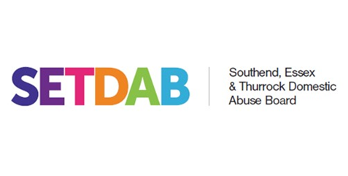

**KEY:**

Open Road

Phoenix Futures (ARC)

Futures in Mind

Essex STARS

Next Chapter

Changing Pathways

Safe Steps (formally SOSDAP)

EYPDAS

**Brightlinsea**

**Clacton-on-Sea**

**Waltham Abbey**

**Westcliff-on-Sea**

**Manningtree**

**Frinton-on-Sea**

**Witham**

**Halstead**

**Sudbury**

**Dedham**

**Billericay**

**Harwich**

**Wickford**