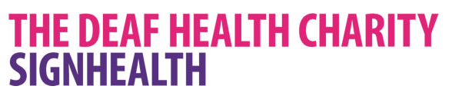

DeafHope from Sign Health
DeafHope is a service giving support to women and children who are caught up in domestic abuse. It is the only service of its kind in the UK which is based in sign language.
Being Deaf puts women at twice the risk of being abused, and makes getting help more difficult. You can’t just pick up the phone and call a help-line when you’re Deaf.
Sign Health’s deaf domestic abuse service, DeafHope, has organised a course of six workshops. These workshops are specifically aimed at Deaf women who need advice about domestic abuse.
The workshops are organised by experienced and qualified Deaf staff, and delivered in British Sign Language. They work with Deaf women, educating them about abuse – what abuse is, the different types of abuse (physical, mental, emotional, financial, sexual) and how to cope in difficult situations.
What happens at the survivor workshops?
- In a safe place, Deaf women can meet other Deaf women who have experienced domestic abuse.
- Our Deaf staff will explain, in BSL, what domestic abuse is, why it happens and what you can do to stay safe.
- They will explain how domestic abuse can make your children feel.
- They will give victim’s advice about coping with abuse, how to be aware of controlling behaviour and how to feel more confident.
Young DeafHope
Young DeafHope is a unique project working with young Deaf people of eleven years and older, to raise awareness of abuse and domestic violence. The aim is to help young people change or avoid abusive behaviour, and to help them to have healthy relationships and stay safe. Deaf children, on average, leave school with a low reading age and miss out on the key messages about abuse given through mainstream media and by word-of-mouth. They cannot access information in the same way as their hearing peers, so deaf children and young people are largely unaware of support networks, or even what constitutes abuse. As a result they are more vulnerable to entering into abusive relationships and neglect.
Psychological therapies service
Deaf people are twice as likely to experience mental health problems such as depression and anxiety compared to hearing people. Communication barriers then make it harder for Deaf people to access the right support. Sign Health’s psychological therapy service breaks down those barriers. The service is delivered in British Sign Language (BSL). All our therapists are Deaf or hearing and fluent in BSL, cutting out the need for an interpreter.
Funding
At present Deaf Hope only covers the London area. However the advocacy service is pan UK but does require payment.
Contacts
www.signhealth.org.uk
SMS 07970 350366
Telephone 020 8772 3241
E-mail deafhope@signhealth.org.uk

